Pre-Travel information

Pre-Travel Information
Now that you have decided on taking one of our great RV’s on a North American road trip, we wanted to share with you some useful information to help you get ready and prepared for your upcoming adventure.
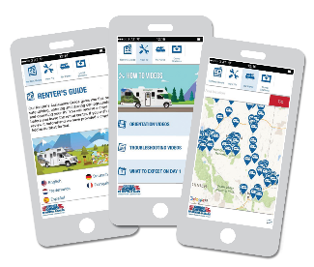
Cruise America/Cruise Canada App
Download our FREE App with a number of helpful resources including videos, renter’s assistance guide and an offline
map to help you plot your RV adventure.
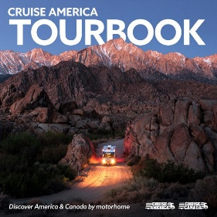
Cruise America Tourbook
Look in our Tourbook for more information about our products, camping, tips and over 35 sample routes throughout North America https://www.rvcheckin.com/tourbook.asp

Our website
www.rvcheckin.com
Our site offers you a whole host of great information when planning your RV holiday. As well as being able to enter your details to speed up the check-in process at the depot, you can also find the following:
- Customer Orientation video https://www.rvcheckin.com/orientation.asp
- What to expect when you arrive at our depots https://www.rvcheckin.com/day1.asp
- Client essential notes http://www.rvcheckin.com/documents/Client_Essential_Notes.pdf
- Features of the RV type you will be hiring https://www.rvcheckin.com/video/default.asp
- Exciting virtual tours on the RV’s https://www.rvcheckin.com/vehicle-360/default.asp
- Where to find our depots https://www.rvcheckin.com/maps.asp
We look forward to welcoming you on your Cruise America/Cruise Canada adventure. If you are on Instagram, follow cruiseamerica and include #cruiseamericarv & #betherenow in a post.
